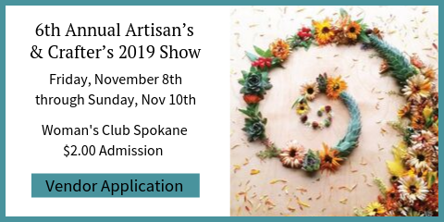

Vendor Information & Application

Woman’s Club of Spokane invites you to submit your work for jury selection for our 2018 fundraising event! Please mark your calendars and spread the word to your friends and family. If you or someone you know would like to have a booth, please fill out the information on the second page and return it via email to events@womansclubspokane.org along with 3-4 images of your current work, you will be showing and an image of your booth set up for jury.

There will be no Preview Night again this year. Set-up will be Friday, November 8, between 10:30 a.m.-5:30 p.m. (unless prior arrangements have been made). Artisans and Crafters may enter the building between 9:00 a.m. -9:30 p.m. for tea and coffee on Show Days. Public shopping hours are Saturday 10 a.m. to 6 p.m. and Sunday 10 a.m. to 4 p.m. Lunch will be provided again both days, as well as water, fruit, snack, etc. Artisans and Crafters must be present both days. Spokane Woman’s Club plans to have volunteers to help you take that needed break. Thank You!

We will jury each application in the order received by category, and the quality of craft, and booth design.

Once you get confirmation that you have been accepted you will be promptly notified. Please send checks made payable to Spokane Woman’s Club – 1428 W. 9th Ave. Spokane WA 99204. Any further questions may be directed to Toni Plastino at the above email or by phone: Club (509)-838-5667; Cell (509) 720-3601.

I know this is short notice for some. Please remember to always save the second weekend of November for the Woman’s Club of Spokane’s Annual Artisans & Crafters Show / Fundraiser… We appreciate our artists and our community. Thank You Linnea Tobias for a fabulous image (Winter Night) to be used in this year’s marketing cards and posters. (Everyone will get some!) The holidays will be here before we know it! Good Luck to you all!

Vendor Application
Name: |  | Phone:
Address:

City: | State: | Zip:
Email:

Are you a Spokane Woman’s Club Member

Description of items for sale:

Washington State UBI: ________________________
City Spokane Business License#________________

Please select ONE category that best describes your work. Jurors will only be selecting a number from each category so our sale will be balanced for happy shoppers.

Accessories Art Baby & Kid Stuff Bags Candles Body Products

Ceramics Clothing Fiber/Knitted Goods Food Housewares Horticulture

Jewelry Kits/Supplies Paper Goods Pets Toys Furniture Home Decor

Other explain___________ Price Point: ___________

Booth Fees: No Canopies or open Frames allowed due to fire codes.
 | Price | Qty. | Total
6' Table | $65
10' x 10' booth | $80
Booth Sharing | +$30.
Booth Sharing: An application must be submitted by both crafters and both accepted. Booth sharing requires $30.00 added to the booth fee. No more than two crafters per booth space.

Table Rental:
No, I will bring my own table __________
Yes, I will rent 1 6’table (+$10) _______
Yes, I will rent 2 6’tables (+$20) _______

Do you require electricity? _____________________________________
There are a limited number of booths that could have access to electricity, at an extra cost of $25 for the entire show. Yes, I would like electrical access ($25) ____________

COMMENTS: __________________________________________________________________________________________________

